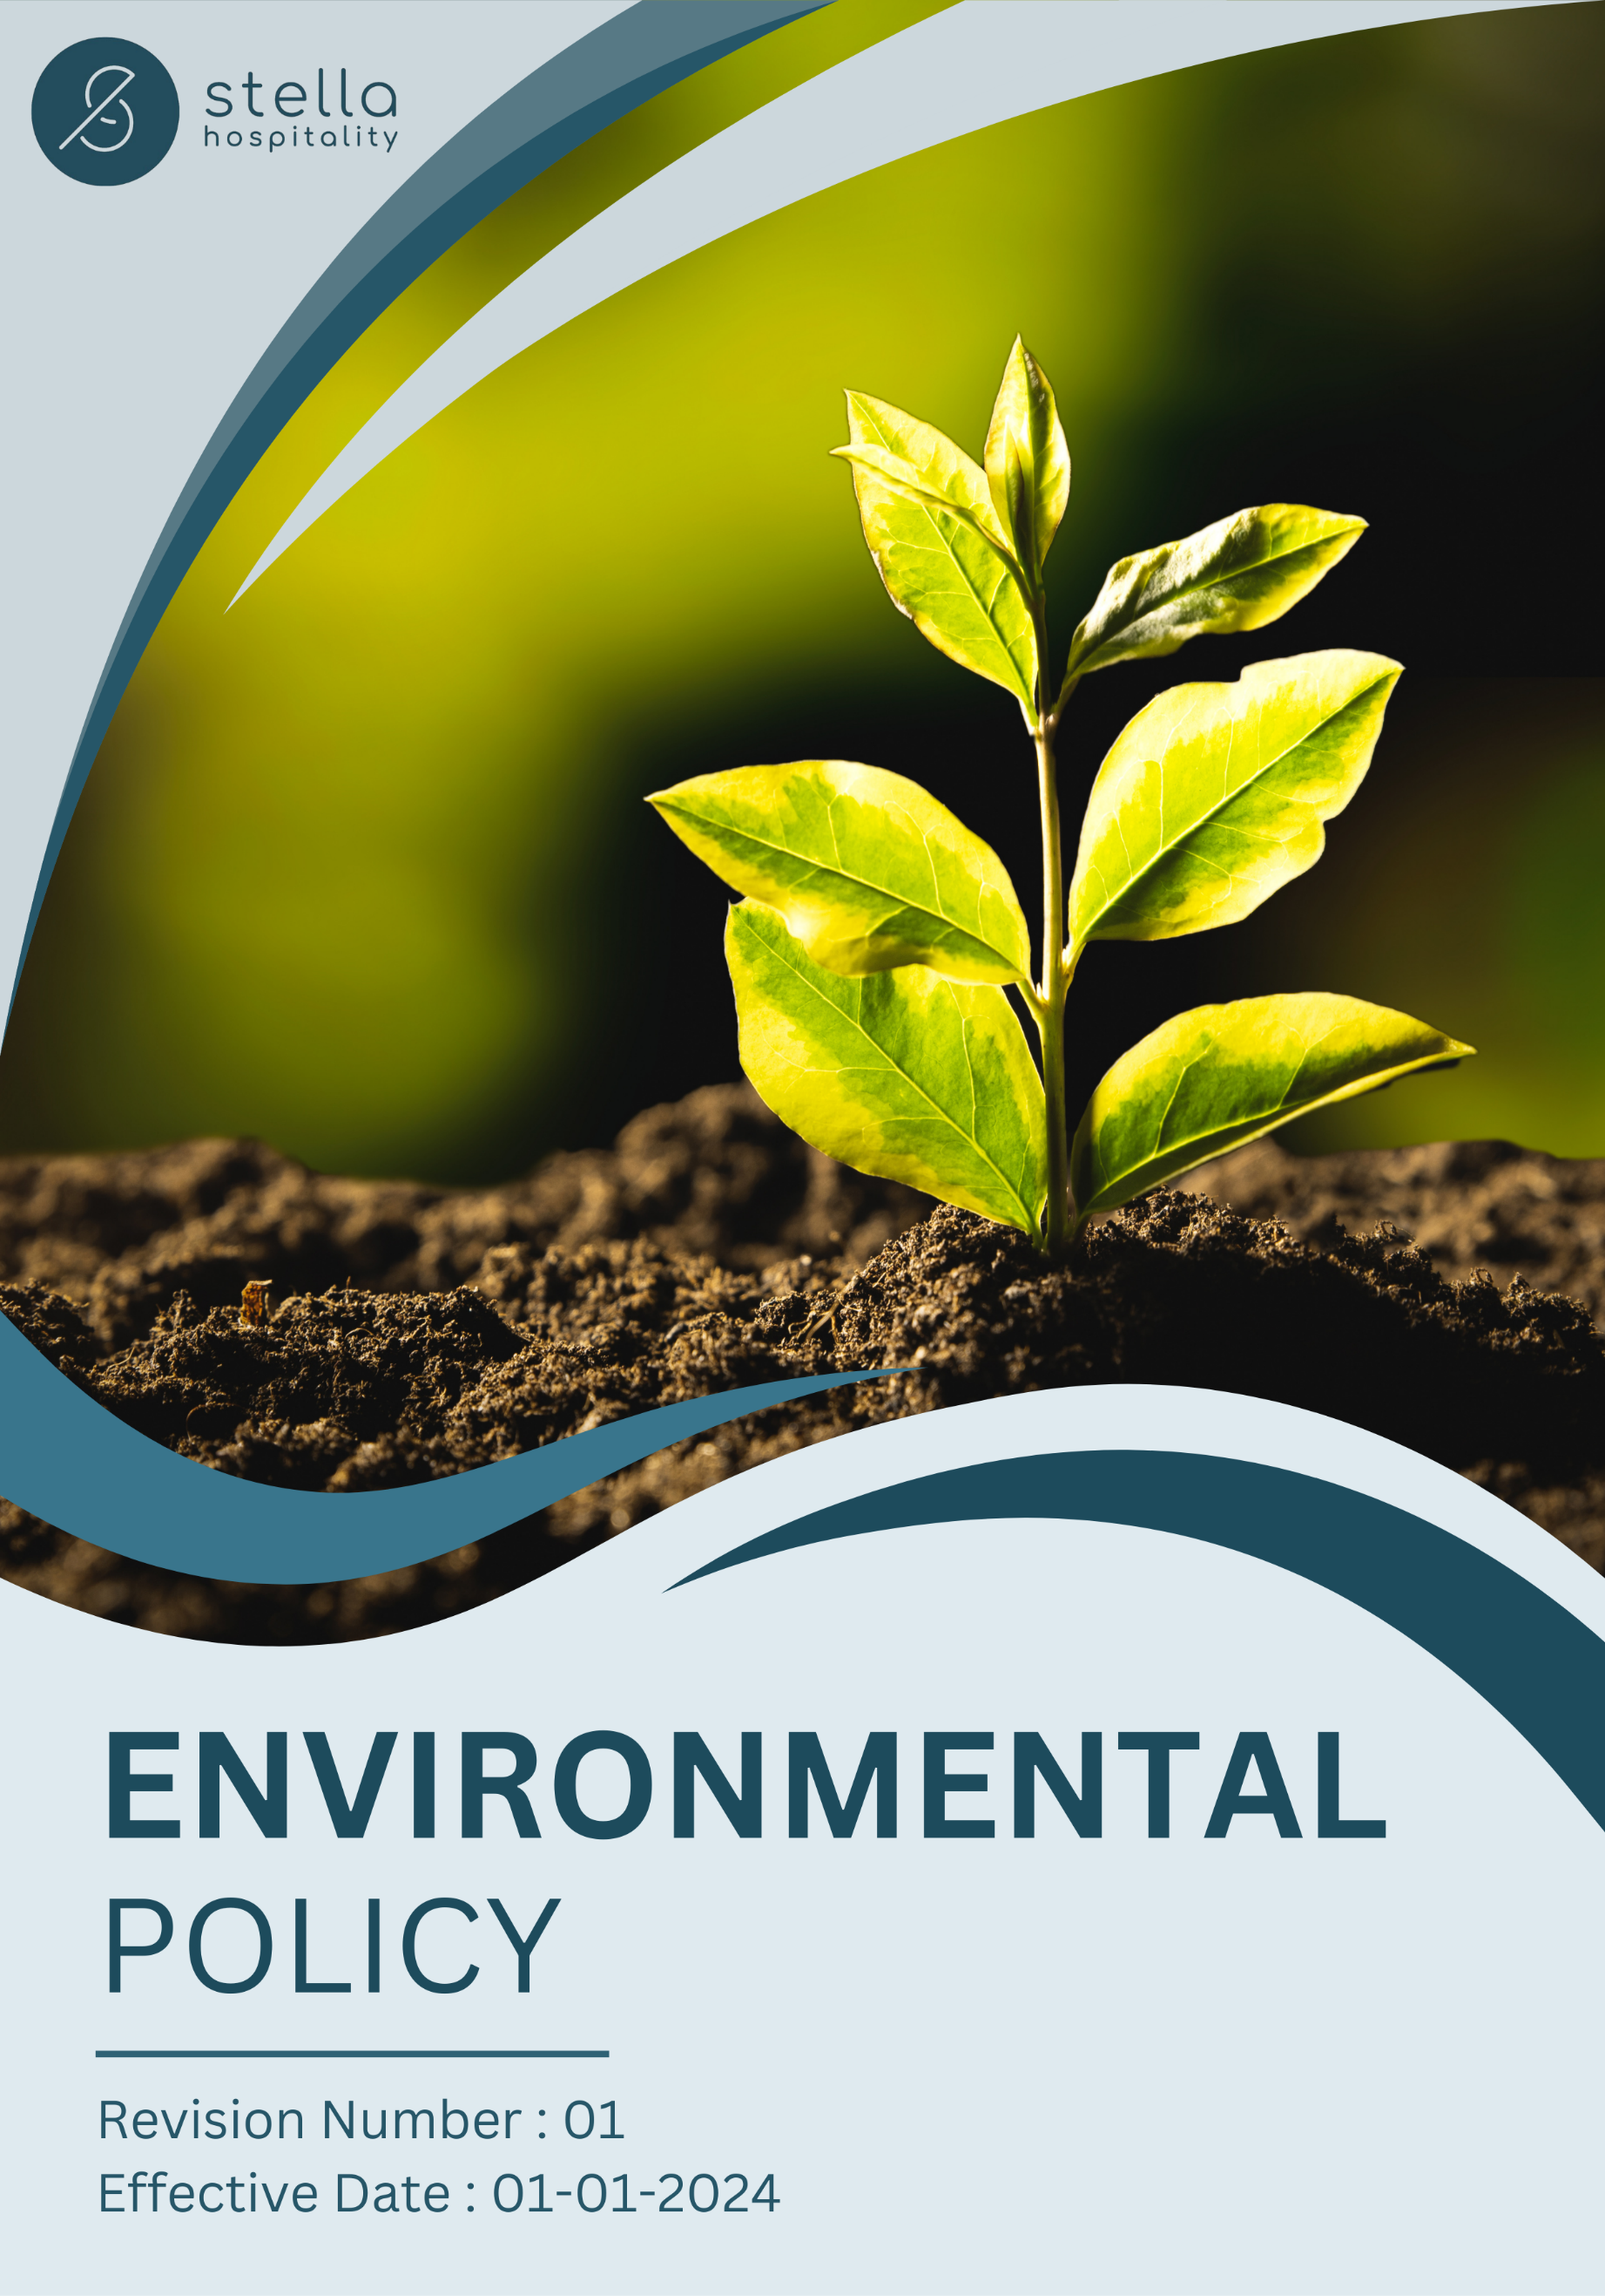
Table of Contents

❖ Introduction: 3
❖ Scope: 3
❖ Environmental Commitment: 4
❖ Quantitative Targets: 4
❖ Action Framework: 6
❖ Roles and Responsibilities: 6
❖ Monitoring and Reporting: 7
❖ Communication and Transparency: 8
❖ Review: 8
❖ Employee Acknowledgement – Stella Hospitality Environmental Policy 9

Introduction:
Stella Hospitality is fully committed to sustainability and responsible environmental stewardship in the hospitality industry. Through our established environmental practices, we continuously strive to reduce our ecological footprint, conserve natural resources, and promote sustainable solutions. Our commitment to environmental responsibility is reflected in our efforts to minimize waste, enhance product lifecycle sustainability, and integrate eco-friendly materials into our amenity solutions. We actively seek innovative approaches to reduce environmental impact while maintaining the highest quality standards in our products and services.

This Environmental Policy reflects our ongoing initiatives aimed at mitigating climate change, protecting biodiversity, and addressing key environmental challenges such as air pollution and product lifecycle impacts. We are already taking significant steps to improve our environmental impact and aim to build on these efforts to drive further progress.

Scope:
This policy applies to all Stella Hospitality offices, distribution centres, supply chain partners, and service providers. It includes all site locations:

Site Name | Address | Primary Function
Saudi | Ad Dahiah, Jeddah, Saudi Arabia. | Warehouse
UAE | Umm Dera - Emirate of Umm Al Quwain - United Arab Emirates. | Warehouse
Jordan | Marka: Nicola Yousef Al Turk St 7, Amman, Jordan. | Warehouse
Jordan | Aqaba: Al-Herafya Area - New Business District-Bilal Nihad Al-Athira Co, Aqaba, Jordan. | Warehouse
Bahrain | Building 2639, Road/Street 1537, HIDD, Block 115, Bahrain. | Warehouse

Environmental Commitment:
Stella Hospitality is dedicated to fostering sustainable solutions by reducing environmental impact and integrating eco-friendly practices into every aspect of our operations. We acknowledge our responsibility to minimize resource consumption, reduce waste, and promote circular economy principles in procurement, packaging, and distribution. Our environmental commitment is reflected in the following key areas:

- Energy Efficiency and Carbon Footprint Reduction: We continuously seek to optimize our supply chain and distribution processes to minimize energy consumption and greenhouse gas emissions. Our logistics network is designed to enhance efficiency, reducing fuel use and emissions while ensuring seamless delivery.
- Materials, Chemicals, and Waste Management: We emphasize the responsible selection of suppliers who provide environmentally friendly raw materials and products. We also train our employees on Materials, Chemicals, and Waste Management.
- Water Conservation: Understanding the importance of water conservation, we encourage responsible water usage in the hospitality sector. We support hotels in adopting refillable and water-conscious amenity solutions to minimize unnecessary water waste.
- Customer Health and Safety: We prioritize the safety and well-being of our customers by ensuring our products meet the highest standards of hygiene, safety, and sustainability. Our sourced products are designed to be free from harmful chemicals, aligning with industry best practices for health-conscious hospitality.
- Environmental Advocacy & Industry Leadership: As a responsible corporate entity, Stella Hospitality actively supports sustainability initiatives and industry collaborations aimed at reducing the hospitality sector’s environmental footprint. We engage in awareness campaigns, sustainable hospitality programs, and continuous improvement efforts to drive meaningful change.
- Compliance with Environmental Regulations: We fully adhere to all environmental laws and regulations in the regions where we operate. Additionally, we proactively seek certifications and industry benchmarks to ensure that our practices align with global sustainability goals.

Quantitative Targets:
- Sets 2022 as the Baseline for tracking our sustainability progress.

- Energy Efficiency:
- Reduce energy consumption by 15% across distribution facilities through energy-efficient technologies and operational optimizations by 2028.
- Increase the use of renewable energy in logistics operations to 50% by 2028.
- Implement smart energy management systems in office and warehouse facilities, reducing unnecessary energy usage by 25% by 2028.

- Carbon Emission Reduction:
- Reduce scope 1 and scope 2 emissions by 15% by enhancing operational efficiency in offices and warehouses and reduce scope 3 emissions by 30% through optimized distribution strategies by 2028.
- Partner with hotels to provide low-carbon amenities, contributing to their net-zero goals by 2028.
- Implement a carbon offset program by 2028, investing in reforestation and renewable energy projects to balance emissions.

- Materials, Chemicals and Waste Management:
- Provide training to all employees on materials, chemicals and waste management by 2028.
- We commit to maintaining 100% compliance of all our products with global chemical standards by 2028.

- Water Conservation:
- Encourage responsible water usage across all office and distribution facilities to reduce water consumption in operations by 25% by 2028.
- Promote refillable and concentrated product solutions, helping reduce water usage by 30% by 2028.
- Support sustainable water management practices in hospitality operations to minimize unnecessary wastewater by 40% by 2028.

- Customer Health and Safety:
- Maintain 100% compliance with product safety and regulatory requirements for hotel amenities by 2028.
- Increase customer satisfaction and sustainability ratings for our products by 25% by 2028, ensuring alignment with global hospitality sustainability certifications.
- Encourage suppliers to develop fully biodegradable amenities that meet dermatological safety standards by 2028.

- Environmental Services and Advocacy:
- Participate in at least 10 international sustainability and hospitality industry forums annually by 2028.
- Launch 10 community-based sustainability awareness initiatives focused on waste reduction, circular economy practices, and eco-conscious hospitality by 2028.
- Form strategic partnerships with 5 global sustainability organizations to enhance industry-wide environmental impact by 2028.

Action Framework:
- Energy Audits: We conduct regular assessments of our office and warehouse facilities to identify inefficiencies in energy consumption and implement corrective measures to optimize energy performance.

- Waste Reduction Campaigns: Employee-driven waste reduction initiatives have been introduced, along with training programs for proper waste segregation. Recycling stations are implemented across all office and distribution locations to maximize material recovery.

- Sustainable Sourcing and Packaging: We collaborate with suppliers to encourage sustainable sourcing practices and minimize waste by using eco-friendly packaging materials.

- Low-Carbon Logistics: Optimizing transportation routes, promoting local sourcing, and shifting to energy-efficient logistics solutions to reduce Scope 3 emissions.

- Community Engagement Programs: Stella Hospitality actively participates in environmental awareness programs, partnering with local organizations to promote sustainable hospitality practices and waste reduction.

Roles and Responsibilities:
Stakeholder | Roles | Key Responsibilities
Leadership & Executive Team | Strategic decision-making, goal-setting, and resource allocation. | - Approve sustainability initiatives and ensure business alignment.  - Engage with regulators, investors, and clients on ESG policies.  - Oversee annual sustainability performance reviews.
Sustainability Task Force | Oversee implementation of sustainability goals. | - Coordinate energy efficiency, waste reduction, and carbon footprint tracking.  - Monitor progress and adjust strategies accordingly.  - Ensure compliance with regulations and reporting standards.
Procurement and Logistics Team | Manage sustainable sourcing, packaging, and distribution. | - Optimize sourcing strategies for eco-friendly products  - Implement low-carbon logistics and distribution practices  - Reduce packaging waste through supplier collaboration.
Employees | Support company-wide sustainability initiatives and foster a green workplace culture. | - Follow company policies on energy conservation and waste management.  - Participate in sustainability training & awareness programs.  - Actively contribute ideas for improving eco-friendly practices.

Monitoring and Reporting:
To ensure transparency, accountability, and continuous progress toward sustainability goals, Stella Hospitality will implement a structured monitoring, reporting, and verification system.

Monitoring Mechanisms:
- Smart energy meters for real-time tracking.
- Monthly waste audits and supplier sustainability checks.
- Employee and customer feedback systems for sustainability improvements.

Reporting Framework:
- Annually ESG Reports for internal review on emissions, waste, and energy efficiency.
- Annual Sustainability Report detailing overall progress, challenges, and third-party audit results.
- Digital Dashboard & Web Portal for real-time KPI tracking and customer access to carbon footprint data.

Audits & External Verification:
- Engaging external auditors for independent verification of emissions, waste management, and ESG compliance.
- Aligning with ISO 14001 (Environmental Management), GRI, LEED, and carbon footprint assessment standards.
- Annual assessments of vendors to ensure ethical sourcing, low-carbon logistics, and compliance with sustainability policies.
- Regular verification of adherence to environmental laws and international sustainability frameworks.

Communication and Transparency:
- The Environmental Policy is publicly available on Stella Hospitality’s website and shared through various stakeholder communication channels.
- Employees are kept informed of updates and expected to integrate these practices into their work.

Review:
The Environmental Safety Office is responsible for overseeing the implementation and review of this policy. This policy will be reviewed annually to ensure its effectiveness and relevance. Updates and changes will be communicated to all stakeholders as necessary, reflecting any operational or regulatory changes, and adapting to evolving environmental challenges.

Approved By:

Designation:

Last Review Date: 01/01/2025 Next Review Date: 01/01/2026

Employee Acknowledgement – Stella Hospitality Environmental Policy
I acknowledge that I have received, read, and understood the Stella Hospitality Environmental Policy. I am aware of the company’s dedication to environmental stewardship, including its efforts in providing sustainable solutions, reducing carbon emissions, enhancing energy efficiency, and minimizing environmental impacts across all operations.
I understand my role in supporting this policy, which includes complying with all applicable environmental laws and regulations, actively participating in Stella's sustainability initiatives, and working toward the company’s environmental goals. I agree to follow energy-saving practices, engage in proper waste management, conserve water, and responsibly use materials in my daily tasks.
Furthermore, I will report any environmental concerns and contribute suggestions for continuous improvement to help Stella achieve its sustainability targets. By signing below, I confirm my commitment to upholding the Stella Hospitality Environmental Policy and supporting the company’s goals.

Employee Name:

Employee Signature:

Date:

